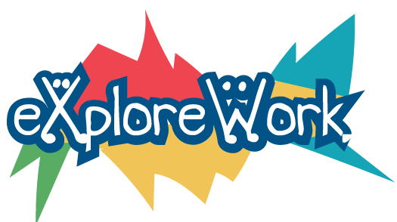
Explore-Work.com: A Trainer’s Guide to Providing Pre-Employment Transition Services to Students with Disabilities

Trainer’s Guide Introduction

Explore-Work.com gives Vocational Rehabilitation (VR) agencies, schools, and other service providers the ability to deliver web-based Pre-Employment Transition Services (Pre-ETS) to students with disabilities.

The training consists of five courses that align with the five Pre-Employment Transition Services activities required by the Rehabilitation Act, as amended by the Workforce Innovation and Opportunity Act (WIOA).

Five Required Pre-ETS Activities | Five Explore-Work Modules
Job Exploration Counseling | Career Planning and Job Exploration
Work Based Learning | Work Experiences
Counseling on opportunities for enrollment in comprehensive transition or postsecondary educational programs at institutions of Higher Education | School Beyond High School
Workplace Readiness Training | Skills for Success
Self-Advocacy | Self-Advocacy

The training courses and activities are meant to be flexible to allow counselors and trainers the ability to adapt content delivery methods and approaches to best fit the needs of student participants. These courses and activities can be used as a standalone option for delivering Pre-ETS training or to supplement and enhance pre-employment transition activities already in place.

This training guide outlines the learning objectives of each course and their alignment with Pre-ETS requirements. In each section, the course lessons and activities are introduced and some tips for presenting these materials are shared.

This guide is meant to spark ideas and identify opportunities for how to use this content to help students with disabilities explore their potential and make a plan for achieving future work and independent living goals.

Lesson / Activity Training Strategies

Following are some strategies for facilitators to consider when presenting these training courses.
- Review previously learned information
- Break learning into small steps
- Preview the activity by talking through the steps of the lesson or activity
- Ask questions to help personalize learning or apply what is learned
- Be prepared to modify the approach to best meet the needs of individual learners
- Use diagrams, graphics or pictures to supplement information presented with words
- Model approaches you want the student to follow
- Provide prompts to help learners remember previous lessons or activity responses
- Repeat important information
- Provide feedback and encouragement

Example Learning Modifications:
- Timing: giving extended time to complete lesson or activity
- Environment: is the learning environment free from distractions as much as possible? Is the setting conducive to learning? If technology is being used, is the student comfortable with using it? If not, spend some time practicing with the technology before starting with training.
- Adapt or supplement format or approach of materials presented:
  - Consider using graphic organizers. Graphic organizers are visual thinking tools that make pictures of thoughts. The pictures demonstrate relationships between facts, concepts, or ideas, and guide your thinking as you design the map or diagram. People who have learning disabilities are often visual learners and thinkers. That means they understand and remember information better when ideas, words, and concepts are associated with pictures, diagrams, charts, and maps. More information about graphic organizers from the Learning Disability Association of America
  - Allow students to respond orally to lesson activities or lessons.

Teacher Accounts

Having a Teacher Account will give you the ability to view all of your students’ accounts from a single dashboard, making it easy for you to oversee their progress, download certificates for them, and even change their passwords if they forget.

Creating New Student Accounts

You can create accounts for all of your students in bulk using a simple form.

- On the Explore-Wori.com, click on the “MY STUDENTS” tab.
- Click on the link entitled “New Student Account Form.”

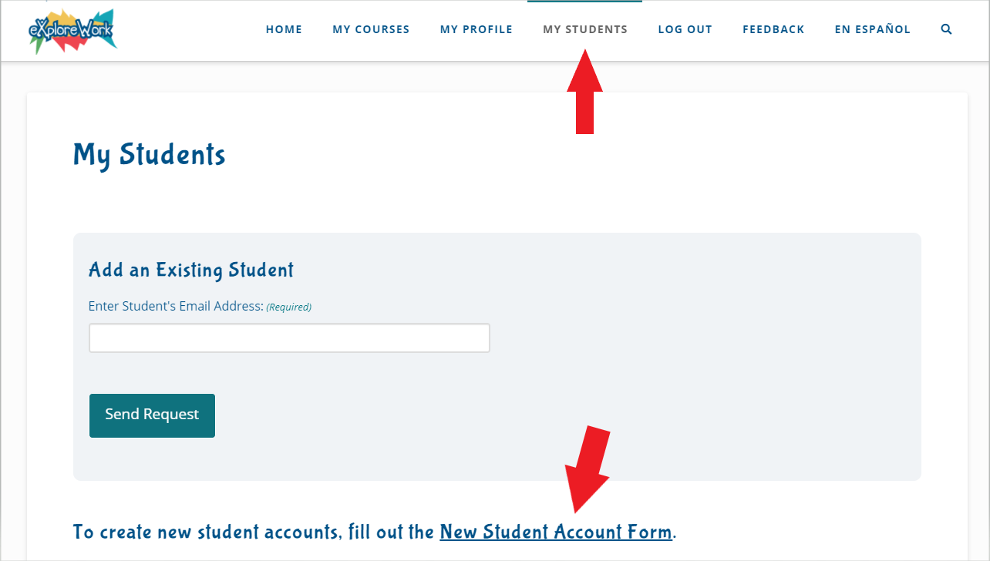

On the next page you’ll see a form to add new student accounts.

All the students that you add will be assigned the same organization and state, so if these are going to be different, you’ll need to submit each location groups separately. You will need to add the first group and then come back to add any additional groups.

- Complete the form. *Note: passwords are case sensitive and may be changed later.
- Click the “Create Now” button when you are done.
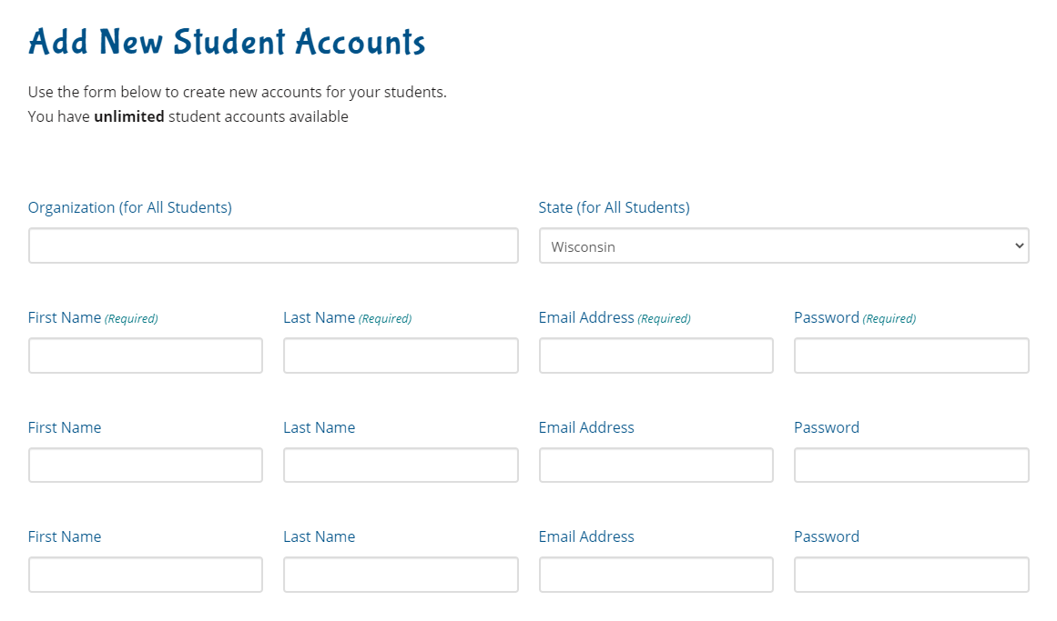

After you submit, the students’ account information will be displayed, and a copy will be emailed to you.
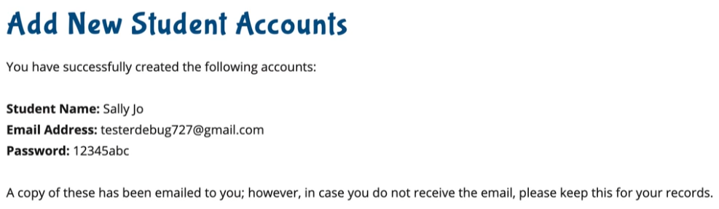

Adding Existing Student Accounts

If a student has already signed up on their own, you also have the option to request access, and add their account to yours that way.

- Go to the “MY STUDENTS” tab.
- Add the student’s email address into the field.
- Click on the “Send Request” button.

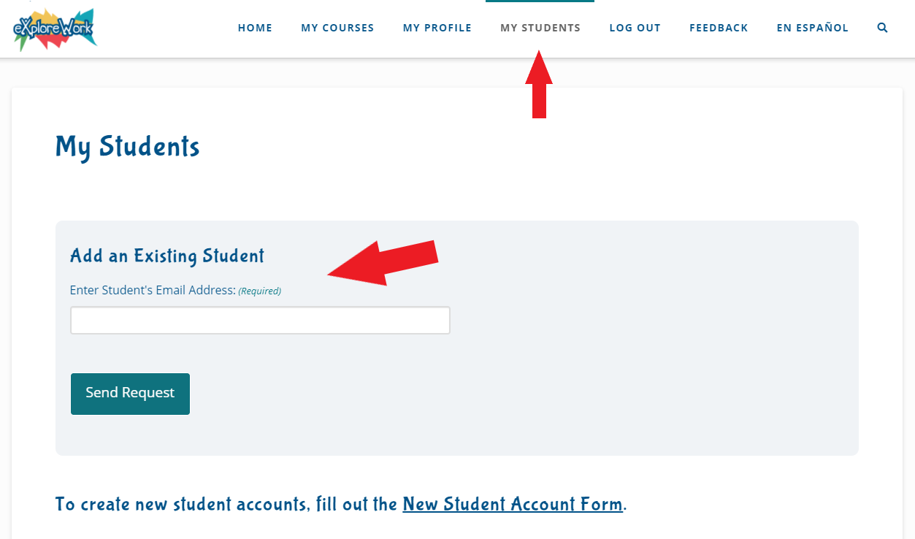

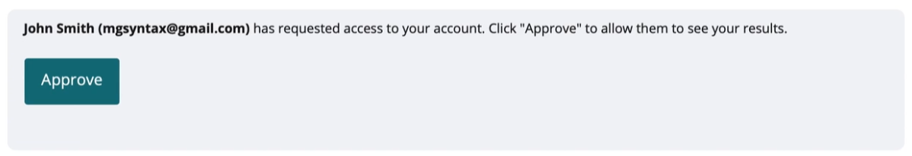
- The student will receive an email notification showing them that you are requesting access, and a notice will be displayed on the top of their “MY PROFILE” tab allowing them to approve it.

Removing a Student from Your Account

If you have a student that you want to remove from your account, you can do so easily while still allowing the student to keep their account.

- Go to the “MY STUDENTS” tab.
- Find the student you want to remove.
- Click on the “REMOVE STUDENT” button associated with the student.
- A confirmation will come up asking if you are sure.

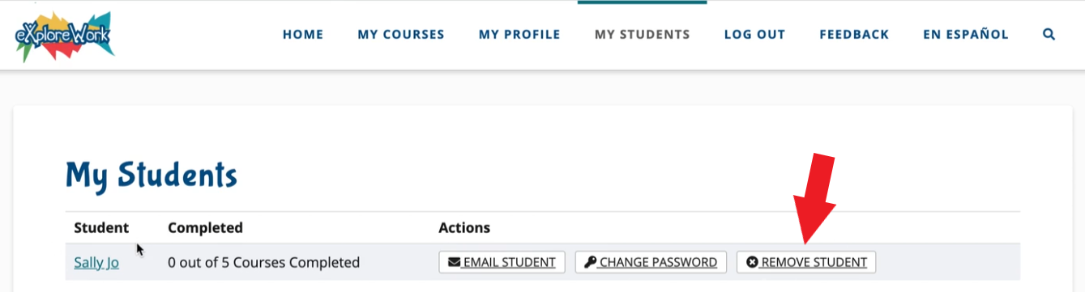

Changing a Student’s Password

- Go to the “MY STUDENTS” tab.
- Find the student you want to update.
- Click on the “CHANGE PASSWORD” button associated with the student.
- Enter the new password on the next page and click “Submit.”
- The student will receive an email with the new password.

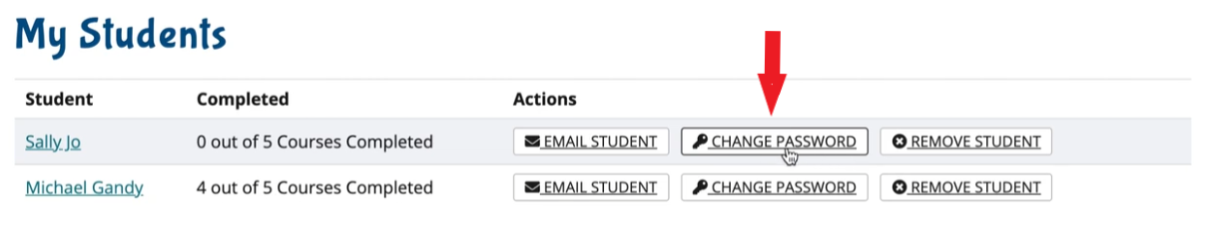

Student Results

- Go to the “MY STUDENTS” tab.
- Find the student you want to view results for. The number of completed courses is displayed next to their name.
- To view more results, click on their name.
- The results page shows when the student last logged in, all the teachers that have access to their account, and a breakdown of each course and activity.

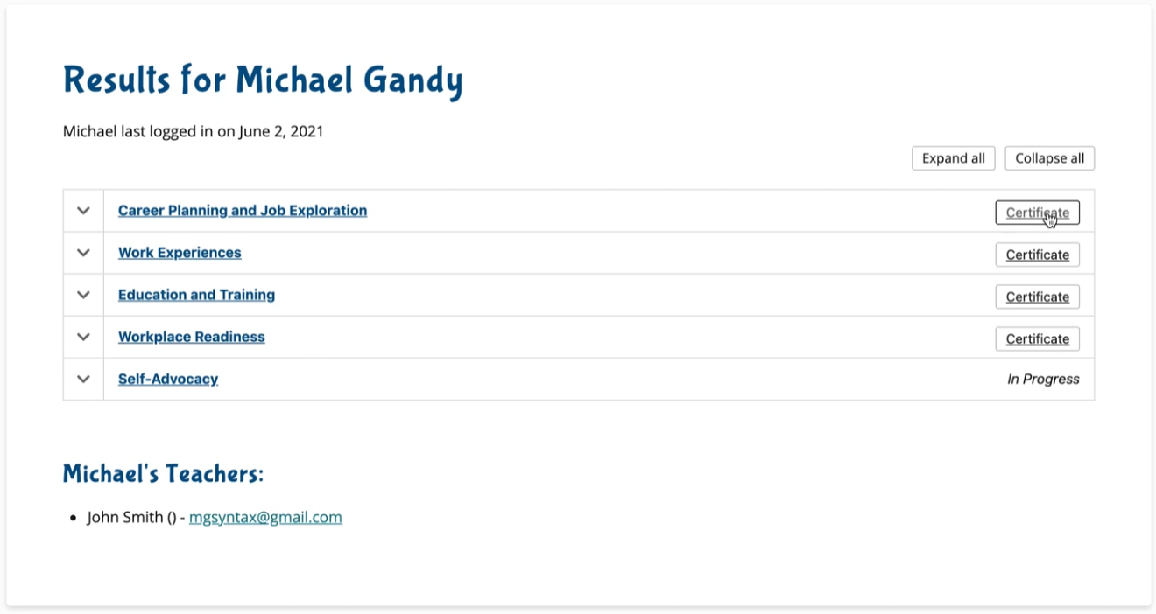

Certificates

If a student has completed a course, you will see a “CERTIFICATE” button show up on the right of the course.

Clicking this will immediately download the certificate as a PDF file.

Course View

To view all the lessons in a course, click on the name of the course or the arrow on the left of it. From the expanded view, you can see:

- The date of completion
- The score they received (if it was a quiz)
- An option to retake the quiz
- A link to see the lesson results.
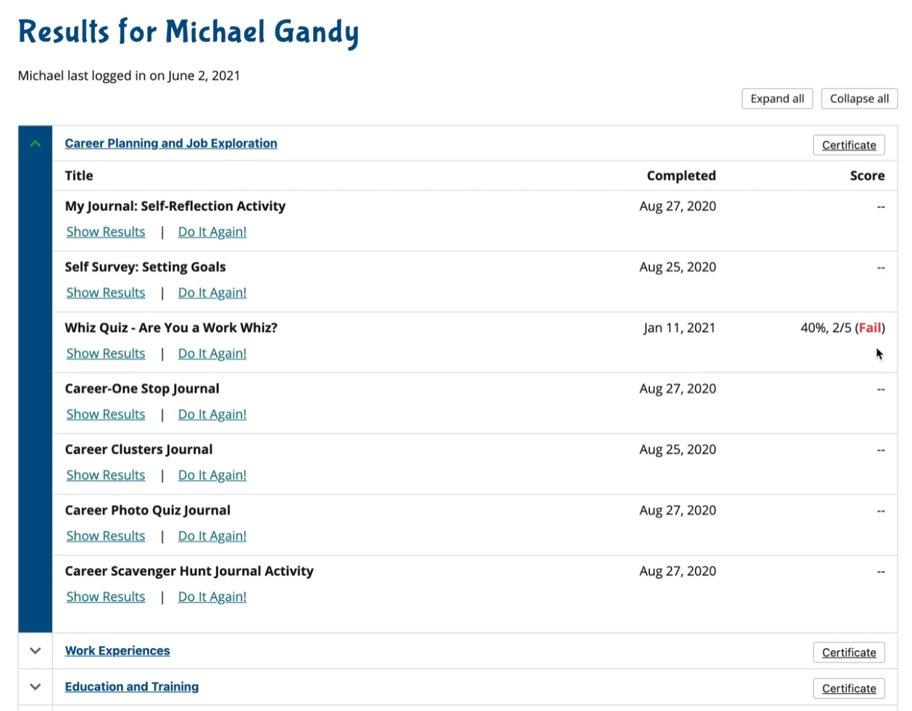

Lesson View

By clicking on “Show Results” you will be able to see the exact results that the student saw when they completed the lesson. This way you can talk them through the results if necessary.

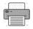
There is also a print button that will allow you to print just the lesson results.
